Task 1:

Ping [www.google.com](http://www.google.com)

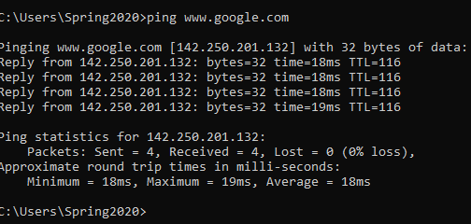

**Task 2:**

**Tracert** [**www.yahoo.com**](http://www.yahoo.com)

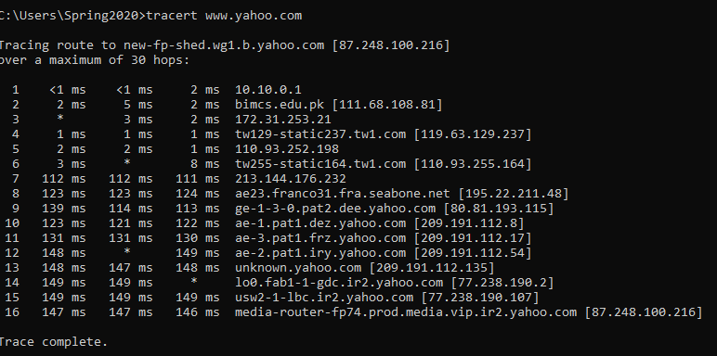

**Task 3:**

**Ping -I 6 www.facebook.com**

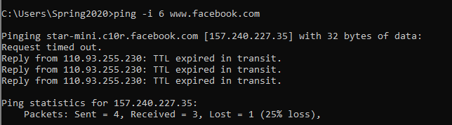

**Reason :**

**The TTL is expired because we have given less number of TTL in the command ping -I 6 of** [**www.facebook.com**](http://www.facebook.com)**. The required TTL for www.facebook .com is 10.**

**TASK 4:**

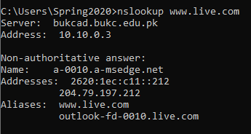

**Non-authoritative answers means that the DNS server that answered your query isn't authoritative for the zone that you're requesting. This is what most results return, since you're probably receiving data cached from your local DNS servers.**

**Task 5 :**

**Differentiate between Ping and PathPing commands:**

**PING:**

The ping command verifies connections to remote computer or computers, by sending ICMP echo packets to the computer and listening for echo reply packets. Ping waits for up to 1 second for each packet sent and prints the number of packets transmitted and received. Each received packet is validated against the transmitted message. By default, four echo packets containing 64 bytes of Computer (a periodic uppercase sequence of alphabetic characters) are transmitted.

You can use the ping utility to test both the computer name and the IP address of the computer. If the IP address is verified but the computer name is not, you may have a name resolution problem. In this case, be sure that the computer name you are querying is in either the local HOSTS file or in the DNS Computerbase.

The Ping stands for Packet Internet Groper.

**PATH PING:**

The PathPing command is **a command-line network utility supplied in Windows 2000 and beyond that combines the functionality of ping with that of tracert**. It is used to locate spots that have network latency and network loss.

**Task 6:**

**Find all Active/ Used IP addresses on your network.**

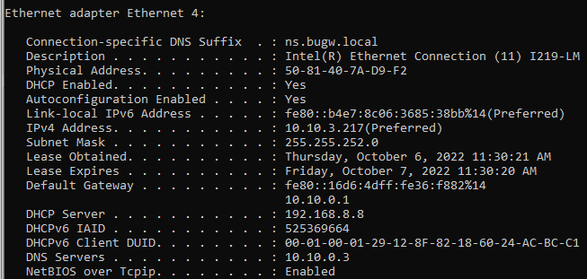

**Task 7:**

**How to verify connection with remote computer**?

